**Pharma sales dashboard**

**Sales(Task 1 to 4):-**

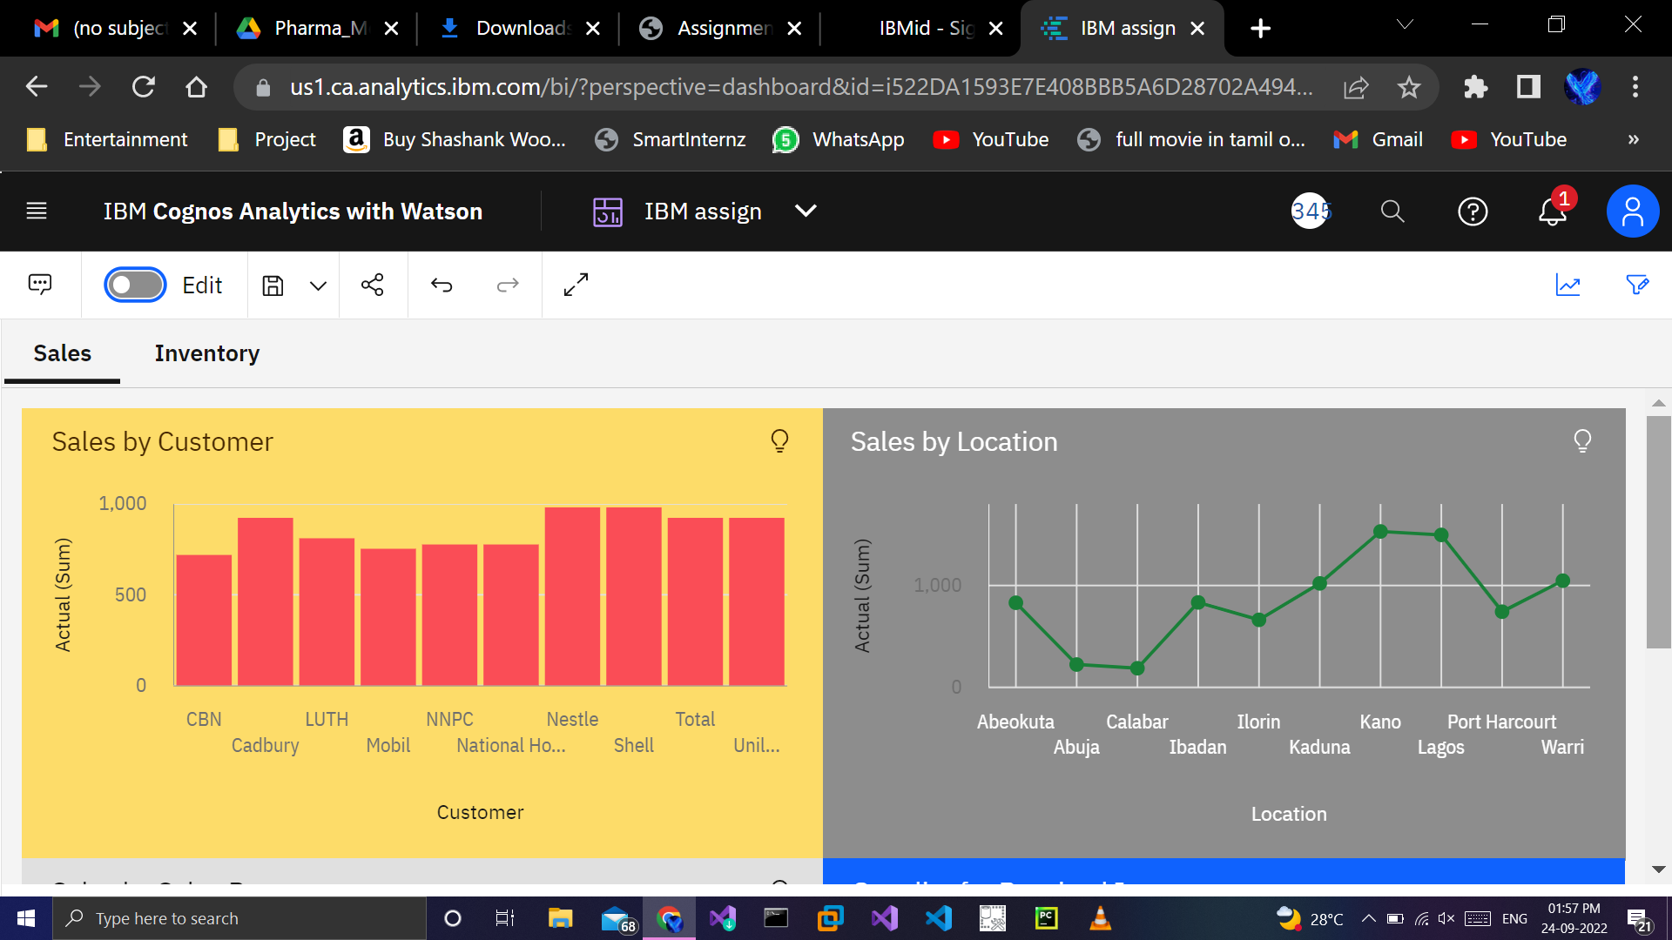

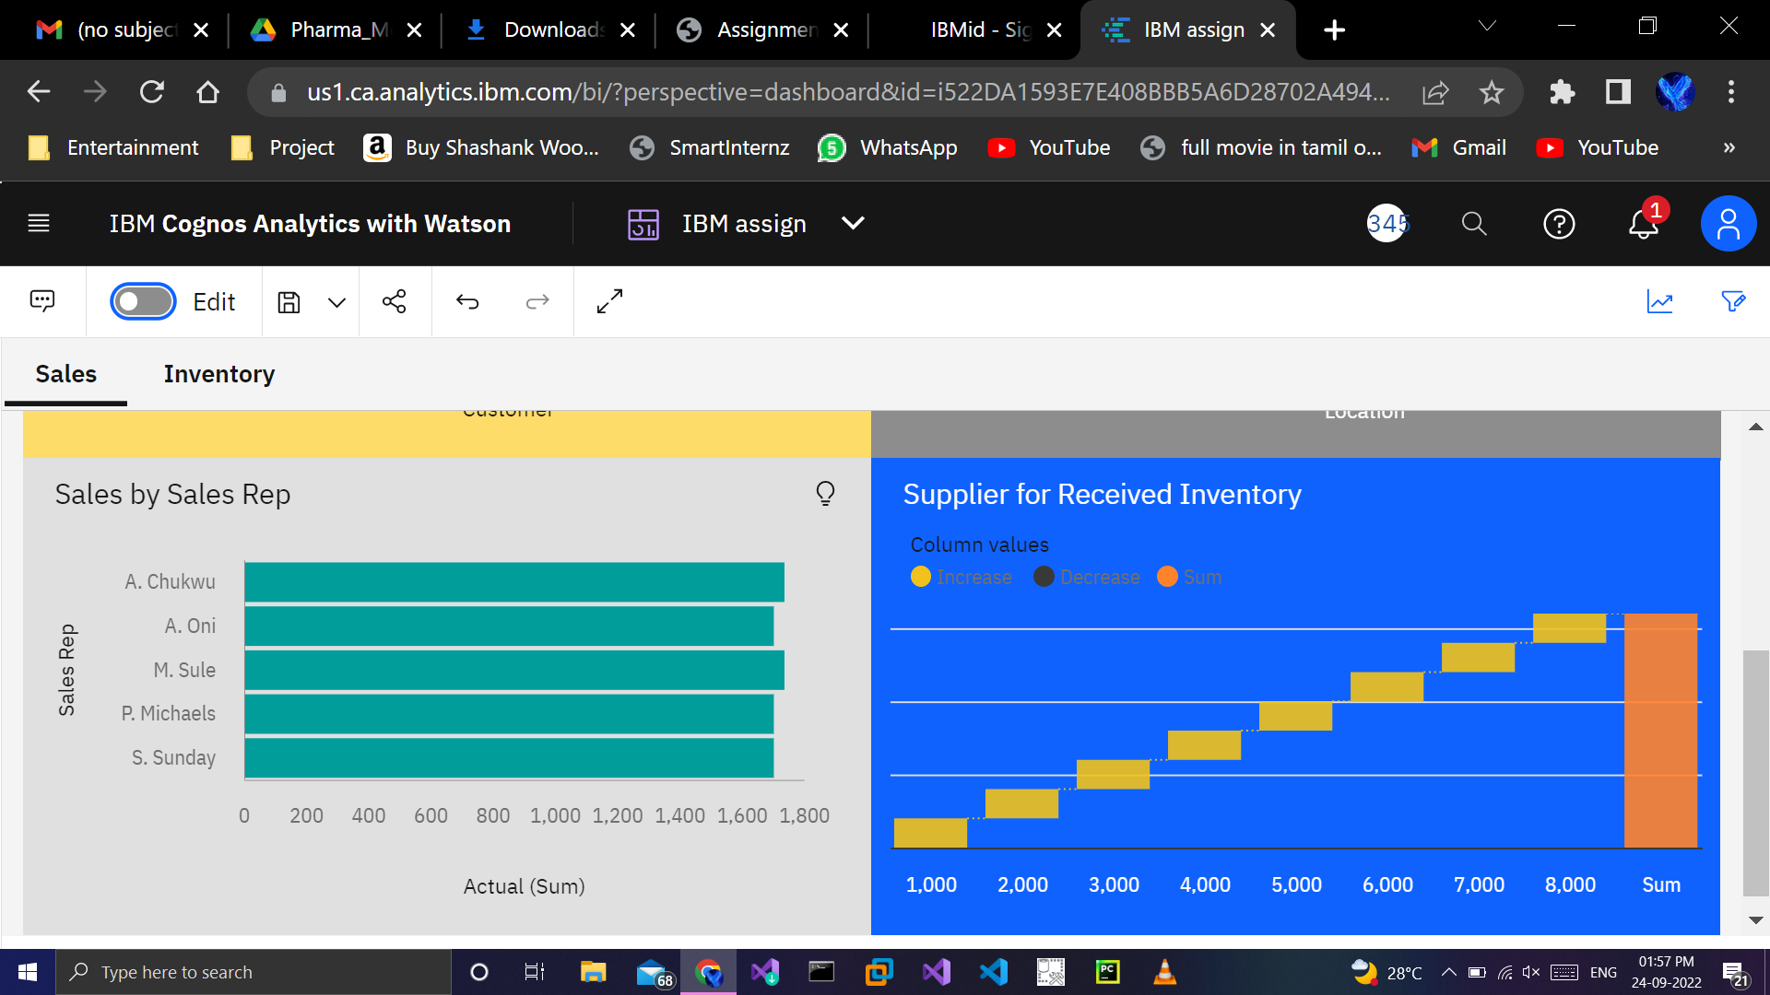

**https://us1.ca.analytics.ibm.com/bi/?perspective=dashboard&pathRef=.my_folders%2FIBM%2Bassign&action=view&mode=dashboard&subView=model0000018369d70e6c_00000000**

**Inventory(Task 5 to 8):-**

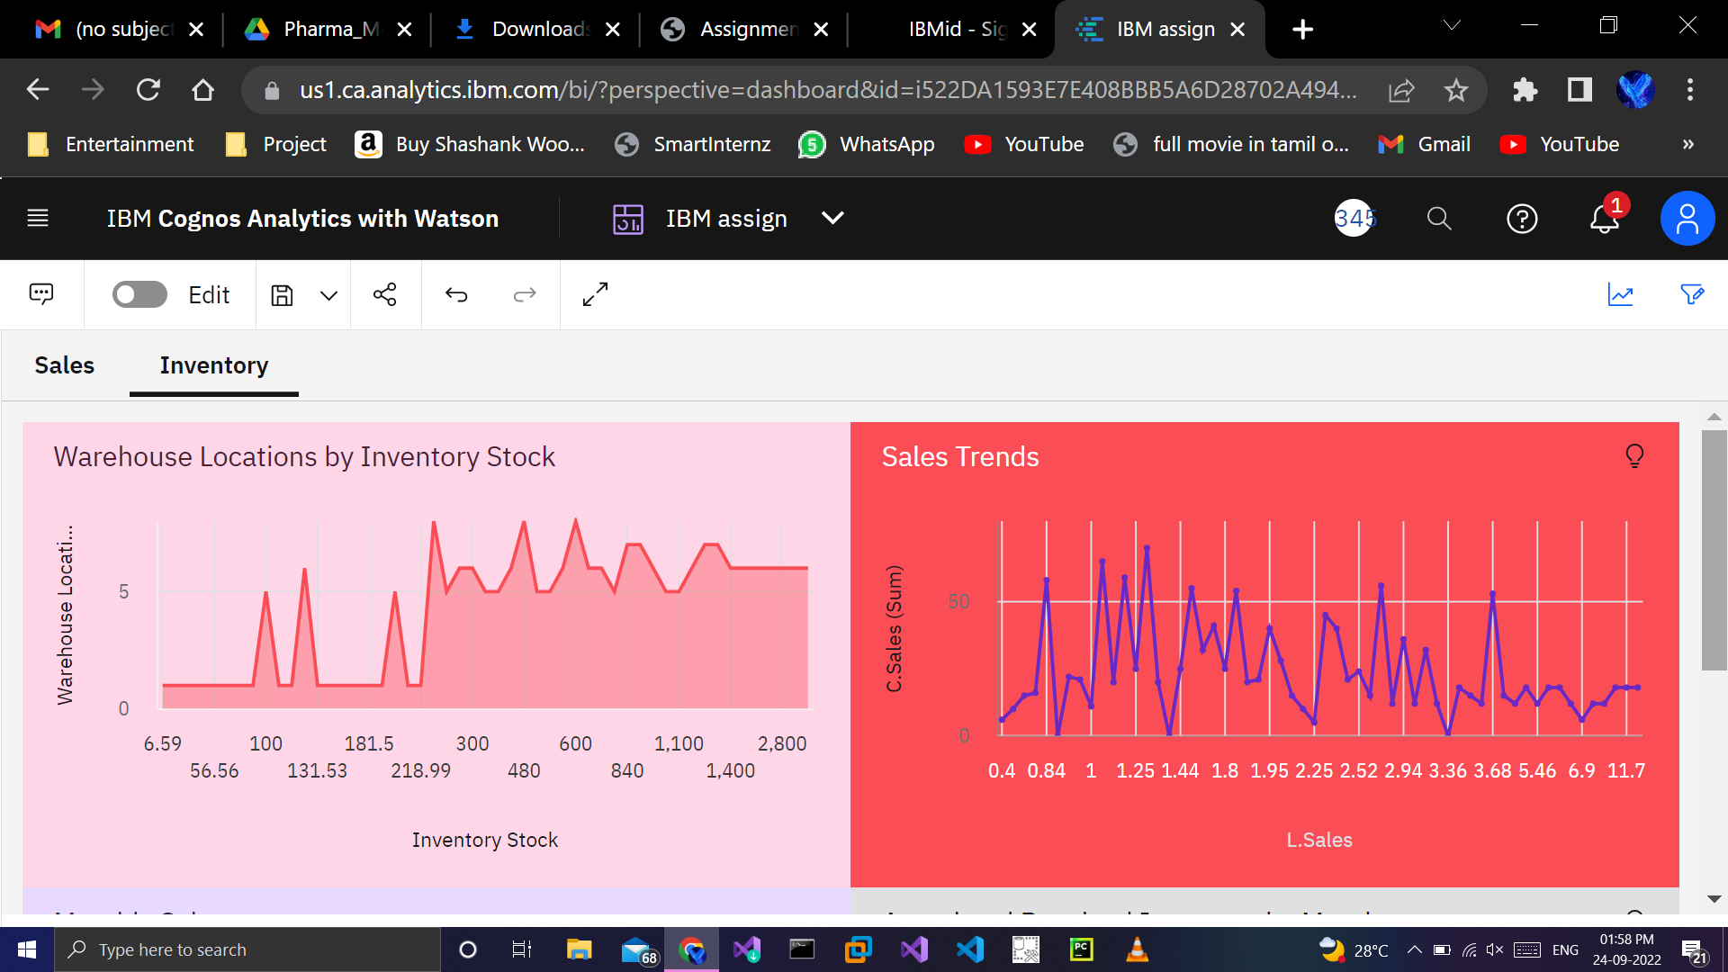

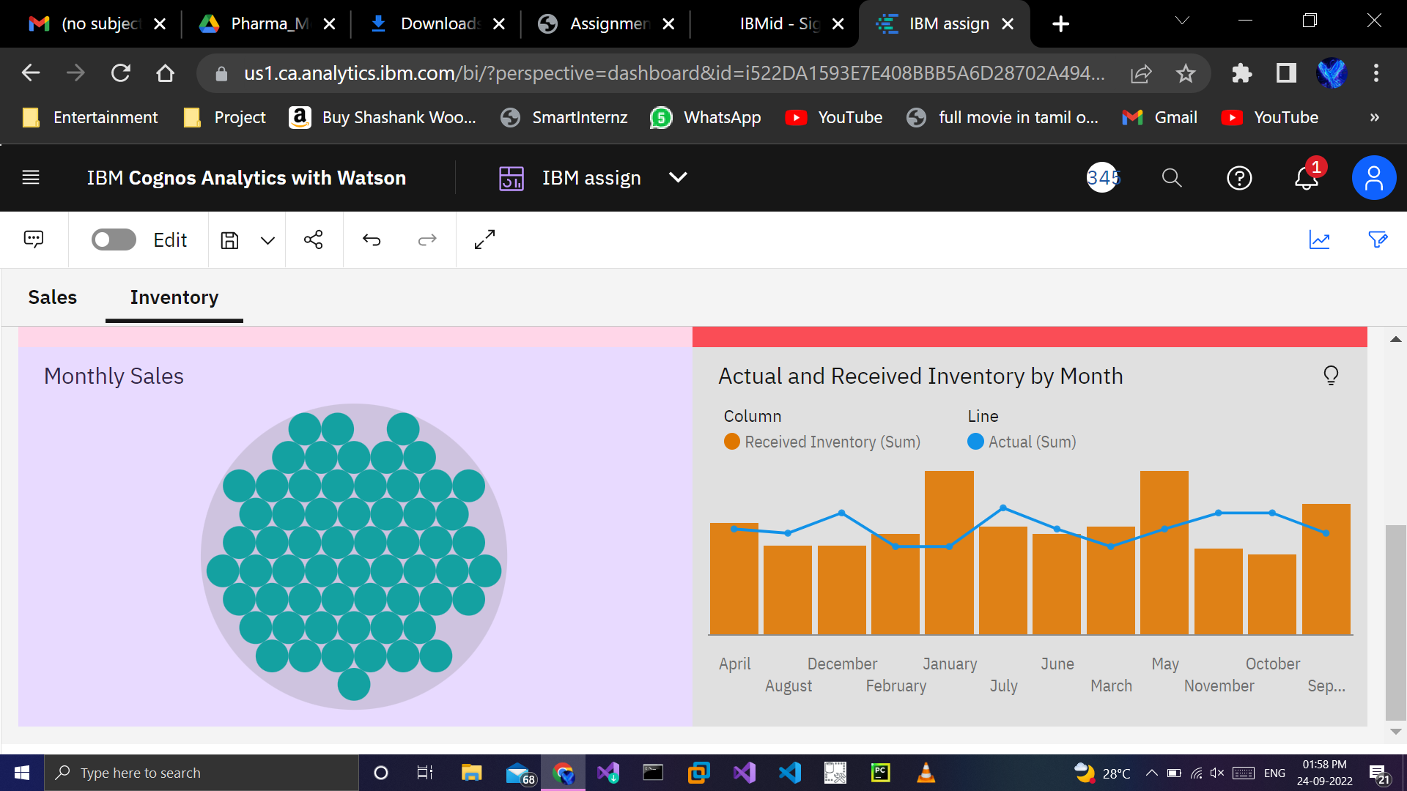

https://us1.ca.analytics.ibm.com/bi/?perspective=dashboard&pathRef=.my_folders%2FIBM%2Bassign&action=view&mode=dashboard&subView=model000001836abd6cd1_00000000